TASK 1: TABLE WITHOUT TIME

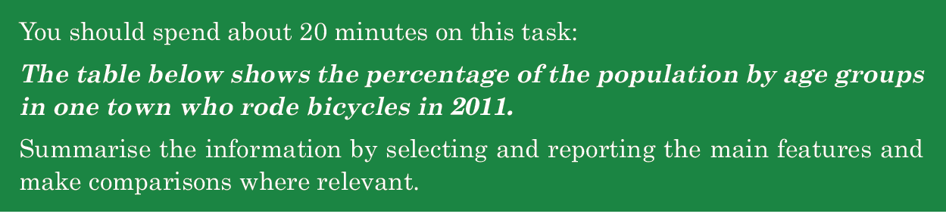

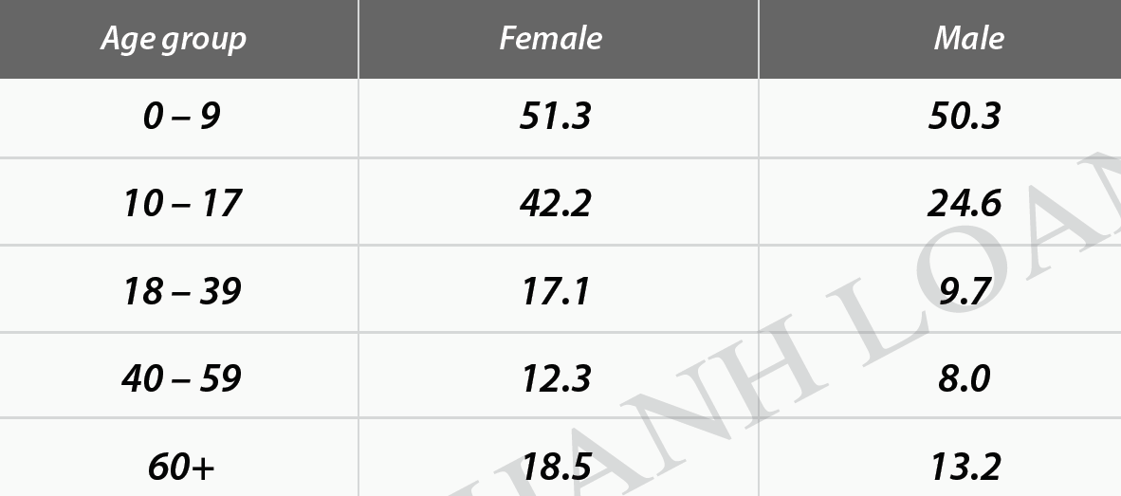
SAMPLE
The table depicts alterations regarding the proportions of people in various age brackets of a town who pedaled in 2011.
Overall, the whole year of 2011 witnessed the lion’s share in the percentages of the youngest age group (0-9) using this means of transport , whereas the reversal was true in the case of the age group 40-59. Additionally, the number of females cycling every day surpassed that of males over the time.
As the chart reveals, under 9-year-old cyclists accounted for the largest proportion that year, with the figure for females outnumbering that of males, at 51.3% and 50.3% respectively. The disparity between the two genders was broadened when it comes to the 10-17 age group, with female figure almost double that of males.
However, as for the older age (18-39), the percentages of both genders in this town commuting by bike declined significantly, amounting to approximately a third of the 10-17 group’s figures. The two oldest groups (40-59 and 60+), on the other hand, bucked the trend somewhat in the numbers of bike riders. Both female figures of these groups outperformed those of male, varying by more or less than 4.5%.

192

Outnumber/ surpass/ overshadow /overtake vượt trội

Respectively
In turn
Consecutively
orderly

Disparity=difference

Về mặt , đề cập đến
As for
In term of
Concerning
Relating to
Regarding
When it comes to

Ngược lai
In contrast,
However,
Meanwhile.
-----while, whereas, whilst-------
Conversely,
On the other hand,
Vary / alter/ oscillate from----to dao động trong khoảng
Between ----and
More or less than=around

======================

TASK 1: TABLE PRACTICE 1

You should spend about 20 minutes on this task.
The table below gives information about consumer spending on different items in five different countries in 2002.
Summarize the information by selecting and reporting the main features and make comparisons where relevant.
Write at least 150 words.
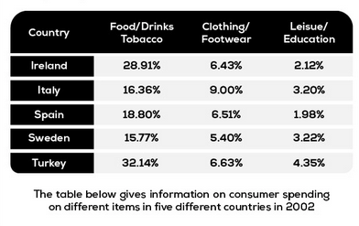

The table depicts the proportions of consumer expending on different items in five nations in 2002.

Overall, all nations spent the most on food/drinks/tobacco, whereas the reversal was true in the case of spending on leisure/education. Additionally, Turkish figure took the lion’s share in expenditure of food/drinks/tobacco and leisure/education, and Italy registered a similar top trend in the remain items.

As the chart reveals, Turkish figure on food/drinks peaked at 32,14%, whereas that of Sweden hit a trough of 15,77% over the same year. Meanwhile, the consumer expending on food/ drinks of the other countries varied from over 15% to less than 19% with the Swedish number bottoming out at 15% in 2002.

As for clothing/footwear, the Italian number of using these items accounted for a maximum of 9% in total numbers of 4 nations. By stark contrast, that of Sweden held a rather minuscule share of 5,4% at the same time. Surprisingly, the quantities of the others approximately equaled each other at over 6% in 2002.

Regarding Leisure/education, whereas Sweden’s figure occupied the majority of 4.35%, that of Spain took up a minimum section of merely 1,98%, as low as half of the Swedish number. The remaining three countries including Sweden, Italy and Ireland reached an equivalent at approximately over 2% in the same year.
216

======================

TASK 1: TABLE PRACTICE 2

You should spend about 20 minutes on this task.
The table below gives information about the proportion of income adults and children spent on 4 common items in the UK in 1998.
Summarize the information by selecting and reporting the main features and make comparisons where relevant.
Write at least 150 words.

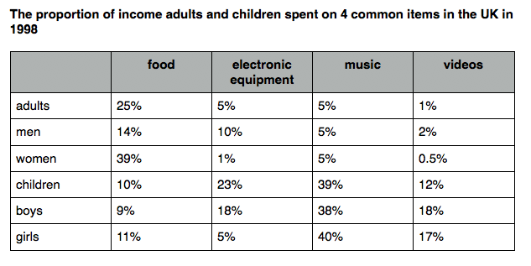

The table depicts alterations regarding the percentage of adults and children expending on 4 different items in the United Kingdom in 1998.
Overall, the whole year of 1998 witnessed the lion’s share in the number of women using the food , whereas the reversal was true in the case of boys. Additionally, the proportion of girls spending on music surpassed those of the others over the same period .

As the chart reveals, the quantity of the women paying on food peaked at 39% . Meanwhile, that of boys hit a trough of 9% in 1998 , and the incomes spending on food of the others ranged from 9% to 14% . However, as for that the electronic equipment was used by children occupied the majority of 23%, nearly fourfold as high as that of adults and girls. Beside,The women’s using on electronic equipment held a minuscule share of 1% , ten times as low as that of men .

Music, on the other hand, bucked the trend somewhat with the numbers spending surpassed those of the others. The quantity of girls expending on music played a dominant role of40%, followed by those of boys and children with 39% and 38% respectively . Plus, the proportion of women accounted 5% , reaching parity with those of men and adults . Additionally, the percentage of boys and girls who spent their money on videos reached 18 and 17% respectively, whereas that of men and women altered from 0,5% to 2 % in 1998.

252 word , 1h15p .

